QUESTIONS(Find the below Output)
----------------------------
QUESTION 1:
-------------

package org.test;

public class A {
public A() {
this("JAVA");
System.out.println("Default const...");
}

public A(int id) {
this(3456.5678f);
System.out.println(id);
}

public A(String name) {
this(12);
System.out.println(name);
}

public A(float sal) {
System.out.println(sal);
}

public static void main(String[] args) {
A a = new A();
}

}
Output :-

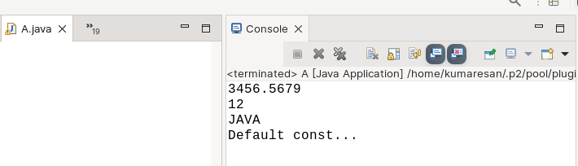
QUESTION 2:
-----------
package org.test;

public class A extends B{
public A() {

System.out.println("Default const...");
}

public static void main(String[] args) {
A a = new A();
}

}
----------------------------------------------------------
package org.test;

public class B {
public B() {
System.out.println("Super class");
}

}

Output :-

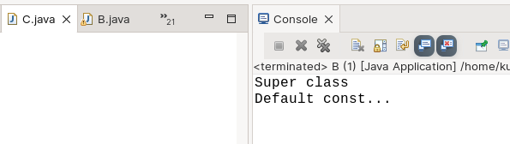
QUESTION 3:
------------
package org.test;

public class A extends B{
public A() {

System.out.println("Default const...");
}

public static void main(String[] args) {
A a = new A();
}

}
-----------------------------------------------------------

package org.test;

public class B {
public B() {
System.out.println("Super class");
}

public B(int id) {
System.out.println(id);
}

}

Output :-

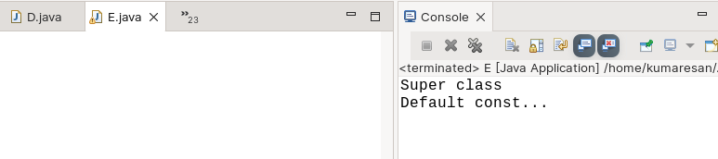
QUESTION 4:
------------
package org.test;

public class A extends B {
public A() {
super(12);
System.out.println("Default const...");
}

public static void main(String[] args) {
A a = new A();
}

}
--------------------------------------------------------------
package org.test;

public class B {
public B() {
System.out.println("Super class");
}

public B(int id) {
System.out.println(id);
}

}

Output :-

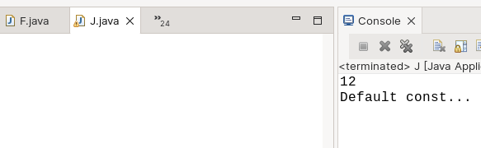
QUESTION 5:
-----------
package org.test;

public class B {

public B(int id) {
System.out.println(id);
}

}
-----------------------------------------------------------
package org.test;

public class A extends B {
public A() {
super(12);
System.out.println("Default const...");
}

public static void main(String[] args) {
A a = new A();
}

}

Output :-

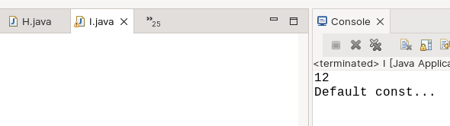
QUESTION 6:
------------
package org.test;

public class A extends B {
public A() {

System.out.println("Default const...");
}

public static void main(String[] args) {
A a = new A();
}

}
----------------------------------------------------------
package org.test;

public class B {

public B(int id) {
System.out.println(id);
}

}

Output :- Error throws class B constructor B() undefined.

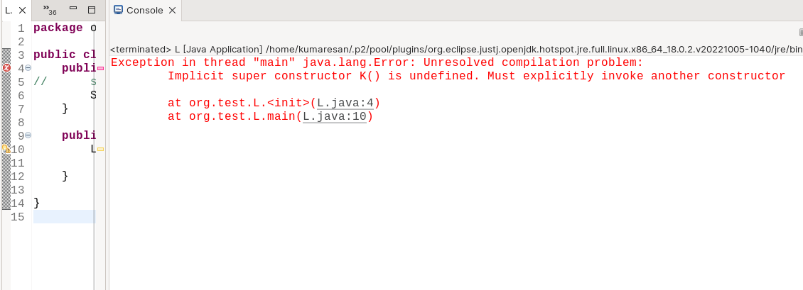
To fix this error call parent constructor B using super keyword in A (or) create default constructor in class B.

After fixing the issue :-

package org.test;

public class A extends B {
public A() {
super(12);
System.out.println("Default const...");
}

public static void main(String[] args) {
A a = new A();

}

}

Now, the output will be -

